Q1 – Call by Value, by Reference and by Pointer 6 Marks
Bloom’s Level: K5 – Evaluate
Problem Context – Hostel Fee Concession Updater
The hostel office applies concessions (merit 10%, sports 15%, single parent 25%) to students’
fees. A function written to apply the concession appears to work when its result is printed
inside the function, but the fee stored for the student never changes.
Your Challenge
Write the concession function three ways – passing the fee by value, by reference and by
pointer. Before running, predict the stored fee after each call, then verify.
Inquiry
Explain where each version stores its parameter, why only two of them change the caller’s
fee, and when a const reference parameter should be used instead.
Design Decision
Several concessions may apply to one student. Decide whether the function should change
the fee in place or return the new fee, and defend your choice.
Predict the Output
Write the exact output of the program below BEFORE running it. Then compile and run it,
and explain every difference between your prediction and the actual output.

Program:1
#include <iostream>
using namespace std;

void change(int a, int &b, int *c)
{
a += 10;
b += 10;
*c += 10;
}

int& bigger(int &p, int &q)
{
return (p > q) ? p : q;
}

void show(int x, int y = 5, int z = 10)
{
cout << x + y + z << " ";
}

int main()
{
int a = 1, b = 2, c = 3;

change(a, b, &c);
cout << a << " " << b << " " << c << endl;

bigger(a, c) = 100;
cout << a << " " << c << endl;

show(1);
show(1, 2);
show(1, 2, 3);

cout << endl;

return 0;
}
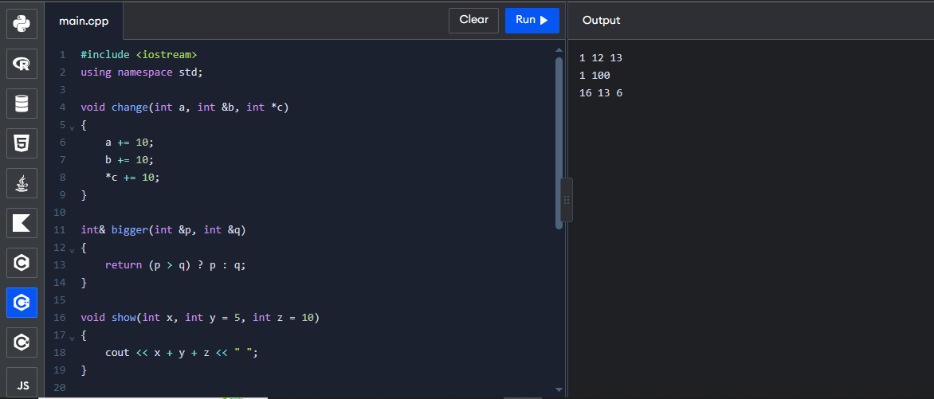

Program:2
#include <iostream>
using namespace std;

void applyByValue(long long fee, int percent)
{
fee -= fee * percent / 100;
}

void applyConcession(long long &fee, int percent)
{
fee -= fee * percent / 100;
}

int main()
{
long long hostelFee = 45000;

applyByValue(hostelFee, 10);

cout << "after call by value : "
<< hostelFee << endl;

applyConcession(hostelFee, 10);

cout << "after call by reference: "
<< hostelFee << endl;

return 0;
}
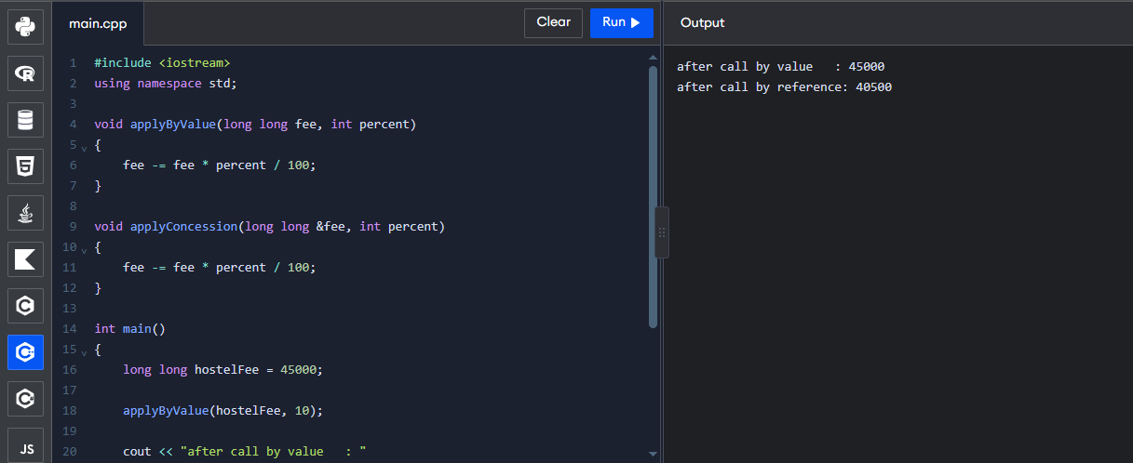

Q2 – Return by Reference and Its Dangers 4 Marks
Bloom’s Level: K5 – Evaluate
Problem Context – Examination Marks Register
The marks register keeps the marks of a class in an array. A function returns a reference to the
highest mark so that a moderation of +2 can be applied directly to it. A second function
returns a reference to a local variable.
Your Challenge
Implement both functions and show:
• How returning a reference lets the caller change the array element (and even use the
call on the left of =)
• What the compiler warns about when a reference to a local variable is returned, and
why using it is undefined behaviour
• The difference between returning a reference, returning a const reference and
returning a copy

Changed Condition
The register is now stored in a std::vector that may grow. Explain why a reference obtained
before the vector grows may become invalid.
Alternative Concept and Complexity Analysis
If the highest mark were returned as an index (int) or as a pointer (int*) instead of a reference
(int&), what would the calling code look like? Analyse the time to find the highest mark

(O(n) in all three) and the space (O(1)), and compare the safety of each when the array is later
replaced by a growing vector.
Evidence Expected
Working functions, compiler-warning evidence, a correct explanation of dangling references
and a justified response to the changed condition.

Program:
#include <iostream>
using namespace std;

int& highest(int a[], int n)
{
int maxIndex = 0;

for (int i = 1; i < n; i++)
{
if (a[i] > a[maxIndex])
maxIndex = i;
}

return a[maxIndex];
}

int main()
{
int marks[5] = {75, 90, 85, 95, 80};

cout << "Highest mark: " << highest(marks, 5) << endl;

highest(marks, 5) += 2;

cout << "After moderation: "
<< highest(marks, 5) << endl;

cout << "All marks: ";

for (int i = 0; i < 5; i++)
cout << marks[i] << " ";

cout << endl;

return 0;
}
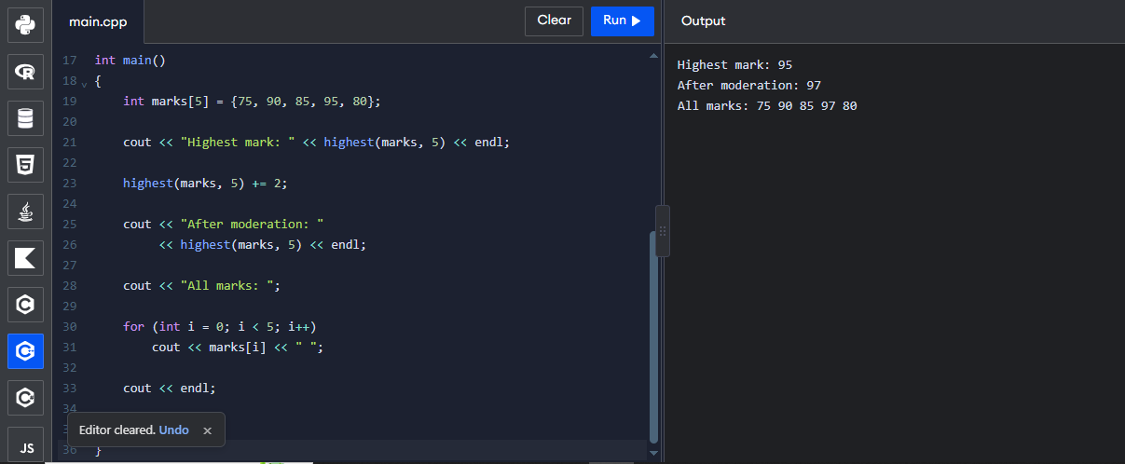
Q3 – Default Arguments and Function Overloading 6 Marks
Bloom’s Level: K5 – Evaluate
Problem Context – Courier Charge Calculator
A courier counter charges by weight; express delivery and insurance are optional. The
developer wrote charge(double weight), charge(double weight, bool express) and
charge(double weight, bool express = false, bool insured = false). The program no longer
compiles.
Your Challenge
Explain the compiler error (ambiguous call). Then design the charge functions so that:
• Common calls are short (default arguments)
• Different kinds of input (weight in grams as int, weight in kg as double, a Parcel
object) are handled by overloading
• No call is ambiguous

Before execution, predict which function each of six calls you design will select, including
charge(2) and charge(2.0f).
Inquiry
Explain how the compiler chooses among overloaded functions (exact match, promotion,
conversion), and why default arguments must be given from the right.
Alternative Concept and Complexity Analysis
If the courier charge took a single Parcel structure with optional fields (or a function
template) instead of several overloaded functions with default arguments, what would the
solution be? Analyse the time of overload resolution (at compile time, no run-time cost) and
the space copied per call, and compare how each design handles a new option.
Evidence Expected
An explained ambiguity, a redesigned set of functions, predicted and observed selections, and
a reasoned explanation of overload resolution.

Program:
#include <iostream>
using namespace std;

class Parcel
{
public:
double weight;
};

int charge(int grams, bool express = false,
bool insured = false)
{
int cost = grams;

if (express)
cost += 50;

if (insured)
cost += 20;

return cost;
}

double charge(double kg, bool express = false,
bool insured = false)
{
double cost = kg * 100;

if (express)
cost += 50;

if (insured)
cost += 20;

return cost;
}

double charge(Parcel p)
{
return p.weight * 100;
}

int main()
{
Parcel p;
p.weight = 3.0;

cout << "Charge 1: " << charge(2) << endl;
cout << "Charge 2: " << charge(2.0f) << endl;
cout << "Charge 3: " << charge(500, true) << endl;
cout << "Charge 4: " << charge(1.5, true, true) << endl;
cout << "Charge 5: " << charge(p) << endl;
cout << "Charge 6: " << charge(2.0) << endl;

return 0;
}
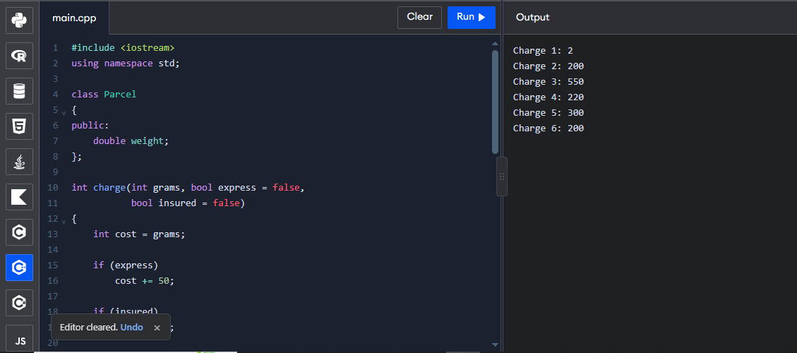
Q4 – Specifying a Class with an Array Inside It 6 Marks
Bloom’s Level: K5 – Evaluate
Problem Context – Savings Account Mini-Statement

A bank wants each SavingsAccount object to remember its last 10 transactions for the mini-
statement printed at an ATM. Older transactions are discarded.

Your Challenge
Specify the class with private data (account number, balance, an array of 10 transactions and
a count) and public member functions deposit(), withdraw() and miniStatement(). Define
some member functions inside the class and some outside using the scope resolution operator.
Inquiry
Explain why the array must be private, what happens when the 11th transaction arrives if you
shift the array versus use a circular index, and the cost of each.
Design Decision
The bank now wants the last 50 transactions. Decide which design changes least and defend
it.
Alternative Concept and Complexity Analysis
If the last 10 transactions were kept in a std::deque (push_back and pop_front), or in a
circular buffer with a start index, instead of shifting a fixed array, what would the solution
be? Analyse the time to add a transaction (O(k) for shifting k elements versus O(1)) and the
space used in each design.
Evidence Expected
A complete class specification, member functions defined inside and outside the class, a
justified handling of the 11th transaction and a defended design.

Program:
#include <iostream>
using namespace std;

class SavingsAccount
{
private:
int accountNo;
double balance;
double transactions[10];
int count;

public:
SavingsAccount(int no, double b)
{
accountNo = no;
balance = b;
count = 0;
}

void addTransaction(double amount)
{
if (count == 10)
{
for (int i = 0; i < 9; i++)
transactions[i] = transactions[i + 1];

count--;
}

transactions[count] = amount;
count++;
}

void deposit(double amount)
{
balance += amount;
addTransaction(amount);
}

void withdraw(double amount)
{
if (amount <= balance)
{
balance -= amount;
addTransaction(-amount);
}
else
cout << "Insufficient balance" << endl;
}

void miniStatement();
};

void SavingsAccount::miniStatement()
{
cout << "Account Number: " << accountNo << endl;
cout << "Balance: " << balance << endl;

cout << "Last Transactions:" << endl;

for (int i = 0; i < count; i++)
cout << transactions[i] << endl;
}

int main()
{
SavingsAccount s(101, 5000);

s.deposit(1000);
s.withdraw(500);
s.deposit(200);
s.withdraw(300);

s.miniStatement();

return 0;
}
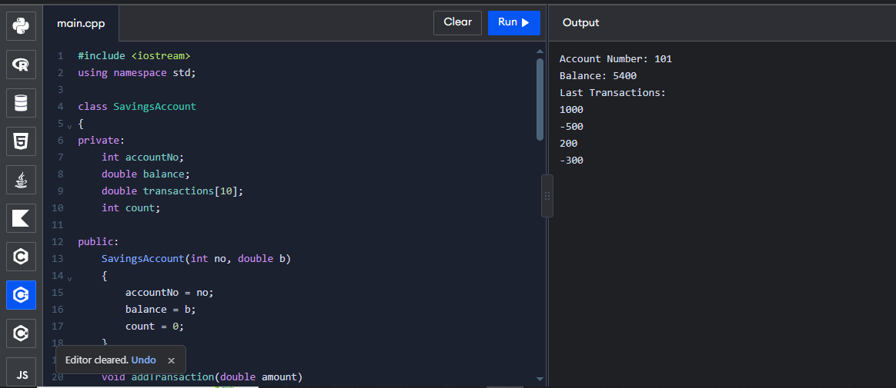
Q5 – Static Members and Arrays of Objects 7 Marks
Bloom’s Level: K5 – Evaluate
Problem Context – College Bus Seat Tickets
The college bus has a fixed number of seats. Each BusTicket object must receive the next seat
number, tickets beyond the capacity go to a waiting list, and the transport office must know
how many seats have been issued without looking at any particular ticket.
Design Starting Point
You are given only the following principle:

Data that belongs to the whole class – not to any one object – should exist only once,
however many objects are created.
Your Challenge
Convert this principle into a class design. Determine:
• Which members must be static, and where a static data member must be defined
• Why a static member function cannot use this or a non-static member
• How an array of BusTicket objects is created and initialised
• What happens to the count when tickets are created inside a loop or a function

Test Your Design
Create an array of tickets larger than the capacity and verify the seat numbers and the waiting
list.
Predict the Output
Write the exact output of the program below BEFORE running it. Then compile and run it,
and explain every difference between your prediction and the actual output.

Program: 1
#include <iostream>
using namespace std;

class Token
{
static int next;
int id;

public:
Token()
{
id = ++next;
}

int get() const
{
return id;
}

static int issued()
{
return next - 100;
}
};

int Token::next = 100;

int main()
{
Token counter[3];

Token extra;

cout << counter[0].get() << " "
<< counter[2].get() << " "
<< extra.get() << " "
<< Token::issued() << endl;

return 0;
}
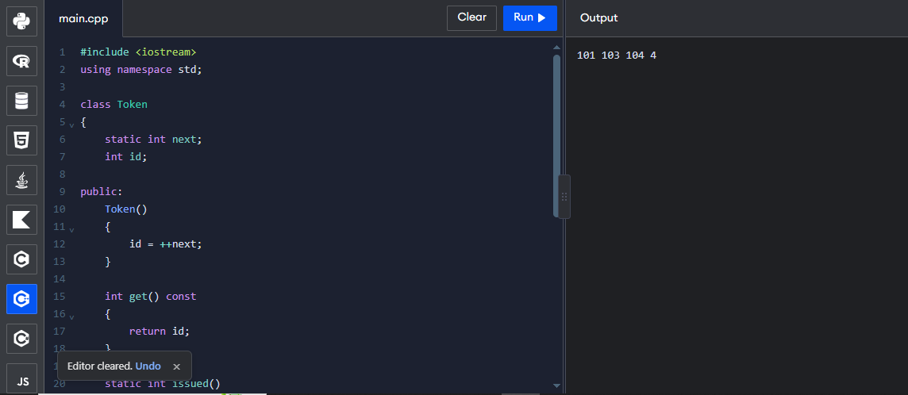

Program: 2
#include <iostream>
#include <string>
using namespace std;

class BusTicket
{
static int issued;
static const int CAPACITY = 3;

int seat;
string name;

public:
BusTicket(const string &n) : seat(0), name(n)
{
if (issued < CAPACITY)
{
issued++;
seat = issued;
}
}

static int count()
{
return issued;
}

void print() const
{
cout << name << ": ";

if (seat)
cout << "Seat " << seat;
else
cout << "Waiting";

cout << endl;
}
};

int BusTicket::issued = 0;

int main()
{
BusTicket trip[4] = {
BusTicket("Asha"),
BusTicket("Bala"),
BusTicket("Chitra"),
BusTicket("Dev")
};

for (const BusTicket &t : trip)
t.print();

cout << "Issued: " << BusTicket::count() << endl;

return 0;
}
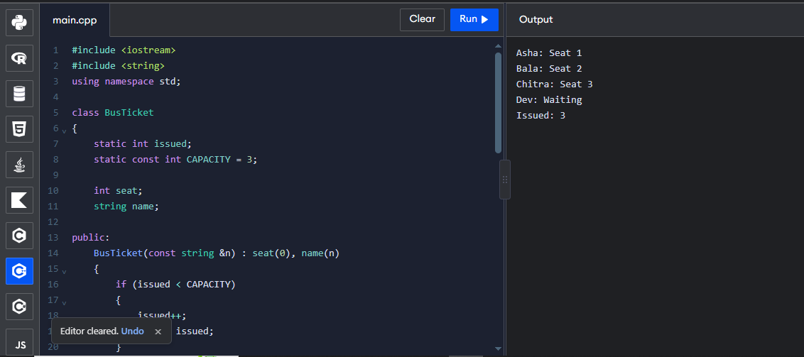
Q6 – Friend Functions and Inline Functions 8 Marks
Bloom’s Level: K5 – Evaluate
Problem Context – Train Journey Planner
A journey planner stores departure and arrival times in a Time class whose hours and minutes
are private. It must compute the minutes between two times and decide which time is earlier,
and these small functions are called millions of times while planning connections.
Your Challenge
Design the comparison. Determine:
• Why a friend function is needed when the function works on two objects equally
• How a friend function differs from a member function in how it is called and what it
can access
• Whether the small functions should be inline, and what inline actually asks the
compiler to do
• What would be lost if the private members were made public instead

Correctness Check
Test with times on either side of noon and the same time twice, and verify by hand.
Growth Investigation
Measure the time for 10,000,000 calls with and without inline (compile with -O0 and with -
O2), and explain the result.
Deployment Decision
Decide whether the friend functions should stay or be replaced by member functions and
getters, and defend your decision.

Program:
#include <iostream>
using namespace std;

class Time
{
int h, m;

public:
Time(int hh, int mm)
{
h = hh;
m = mm;
}

friend int minutesBetween(const Time &a, const Time &b);

friend bool earlier(const Time &a, const Time &b);
};

inline int minutesBetween(const Time &a, const Time &b)
{
int t1 = a.h * 60 + a.m;
int t2 = b.h * 60 + b.m;

int diff = t1 - t2;

return (diff < 0) ? -diff : diff;
}

inline bool earlier(const Time &a, const Time &b)
{
return (a.h * 60 + a.m) < (b.h * 60 + b.m);
}

int main()
{
Time departure(9, 45), arrival(13, 10);

cout << minutesBetween(departure, arrival) << " "
<< boolalpha << earlier(arrival, departure) << endl;

Time t1(10, 30), t2(10, 30);

cout << minutesBetween(t1, t2) << " "
<< earlier(t1, t2) << endl;

Time t3(11, 50), t4(12, 10);

cout << minutesBetween(t3, t4) << " "
<< earlier(t3, t4) << endl;

return 0;
}
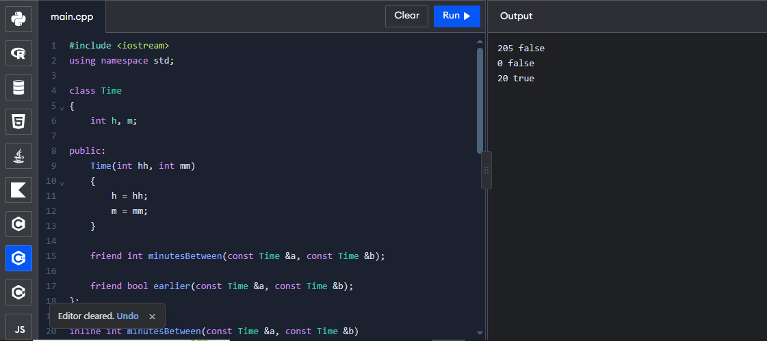

Q7 – Diagnose, Redesign and Validate 13 Marks
Bloom’s Level: K5 – Evaluate
Review the evidence you generated while working on Q1–Q6. Select ONE program that
shows a significant limitation as the data grows or the requirement changes.
You are not permitted simply to replace your code with a library facility and claim it is better.
You must understand the problem first and then develop an appropriate redesign.

A. Diagnose the Limitation – 2 Marks
Using your own evidence, identify where the design fails or slows down and which
characteristic of the original design causes it.
Evidence Expected
A precise diagnosis supported by evidence from your original program.
B. Define the Design Objective – 2 Marks
State a measurable objective for the redesign.
Evidence Expected
A clearly stated objective derived from the identified limitation.
C. Design the Revised Solution – 4 Marks
Explain what you have changed in the class or function design, which C++ feature you use,
whether extra memory is needed, and any new trade-off. Provide a class diagram or
pseudocode.
Evidence Expected
A coherent redesign directly addressing the diagnosed limitation.
D. Predict Before Implementing – 1 Mark
Predict the improvement and the measure in which you expect it.
Evidence Expected
A clear, testable prediction.
E. Implement and Validate the Redesign – 2 Marks
Compare Original → Redesigned using the same tests and measurements.
Evidence Expected
Comparable evidence for both versions.
F. Defend the Final Design – 2 Marks
Evaluate whether the objective was achieved, new costs, and where the original may still be
preferable. A redesign that does not outperform the original is not automatically unsuccessful
if you correctly explain why.
Evidence Expected
A critical, evidence-based evaluation and a defensible conclusion.

Program:
#include <iostream>
using namespace std;

class SavingsAccount
{
double transactions[10];
int start, count;

public:
SavingsAccount()
{
start = 0;
count = 0;
}

void addTransaction(double amount)
{
int index;

if (count < 10)
{
index = (start + count) % 10;
count++;
}
else
{
index = start;
start = (start + 1) % 10;
}

transactions[index] = amount;
}

void display()
{
cout << "Last Transactions:" << endl;

for (int i = 0; i < count; i++)
{
int index = (start + i) % 10;
cout << transactions[index] << endl;
}
}
};

int main()
{
SavingsAccount s;

s.addTransaction(1000);
s.addTransaction(2000);
s.addTransaction(3000);
s.addTransaction(4000);

s.display();

return 0;
}


